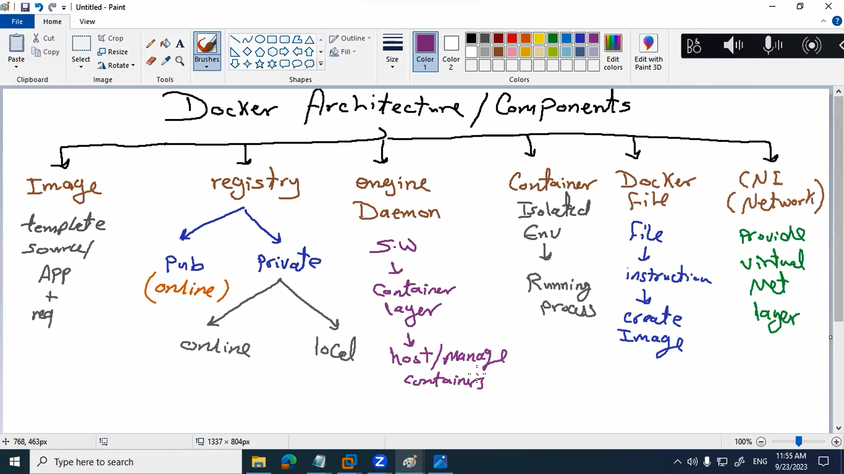

*Engines* create the *container* from docker *image* which store in *registry* using the *docker file* and these containers can communicate with each other using the *CNI* container network interface.

* We can containerize our app or create an empty container and setup my app with all it’s dependencies.
* Alpine is the base image that we can create an empty container

Commands:

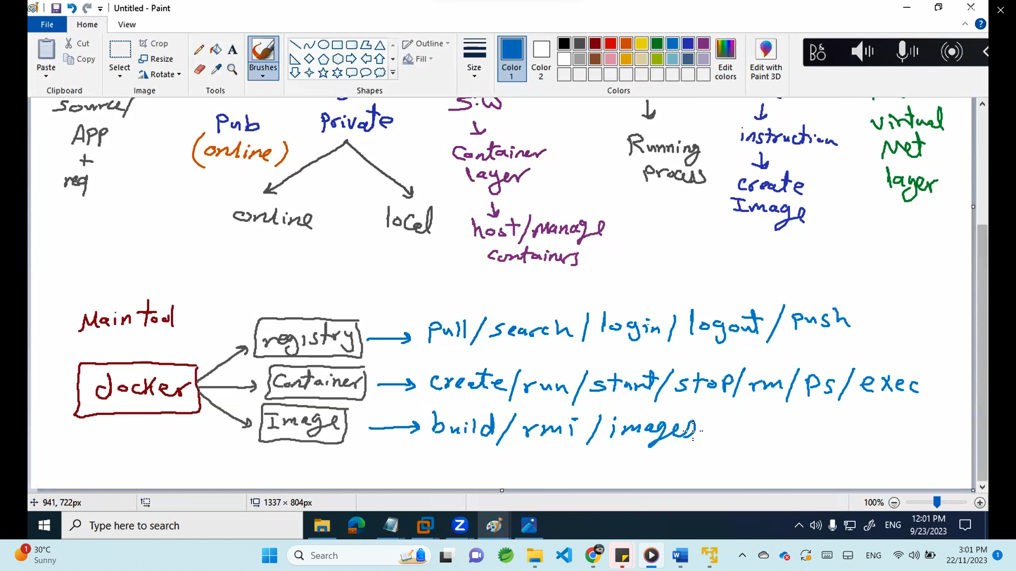

|  |  |
| --- | --- |
| Command | Explain |
| Docker | Get all docker commands |
| Docker images | List all docker images |
| Docker pull alpine | Download alpine docker image from the internet |
| Docker search alpine | Search for any image |
| Docker login | Login to your registry |
| Docker ps | List running containers |
| Docker ps -a | List all containers even they are not running |
| Docker create –name=lab1 -p 8081:80 httpd:latest | Create container in port 8080 from image httpd |
| Docker start lab1 | Start already existing container |
| Docker rm lab3 | Delete stopped container |
| Docker exec -ti lab1 ls /etc بدخل انفذ حاجه جوه الكونتينر | Exec -i interactive and u to generate tty |
| Docker exec -ti lab1 cat /etc/os-realease | cat /etc/os-realease in lab1 |
| Docker exec -ti lab1 cat /etc/os-realease --color | --color if I want to color the output of the command |
| Docker exec -ti lab1 bash | Login into the container |
| Exit | Exit of I logged in any container and I want to exit |
| Double tab | If we are logged into any container and we want to see all commands can be run |

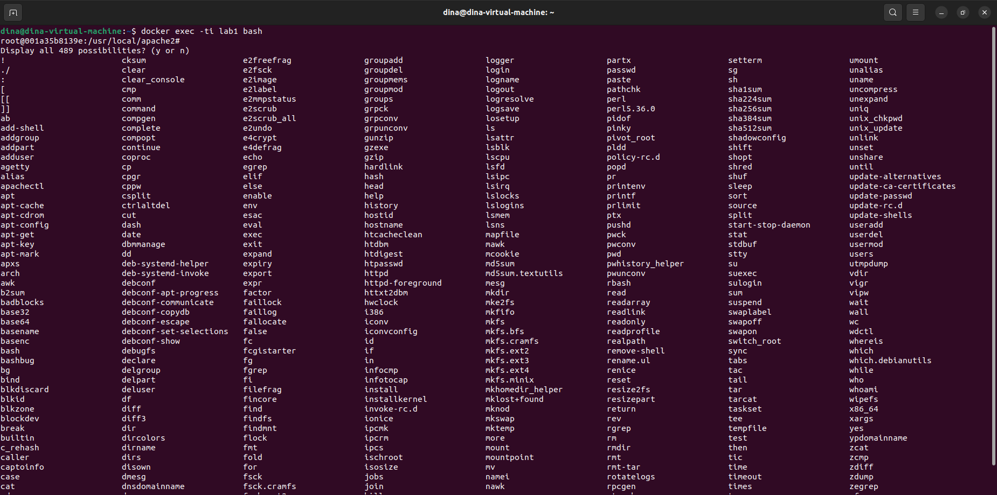

To install any pkg in the container

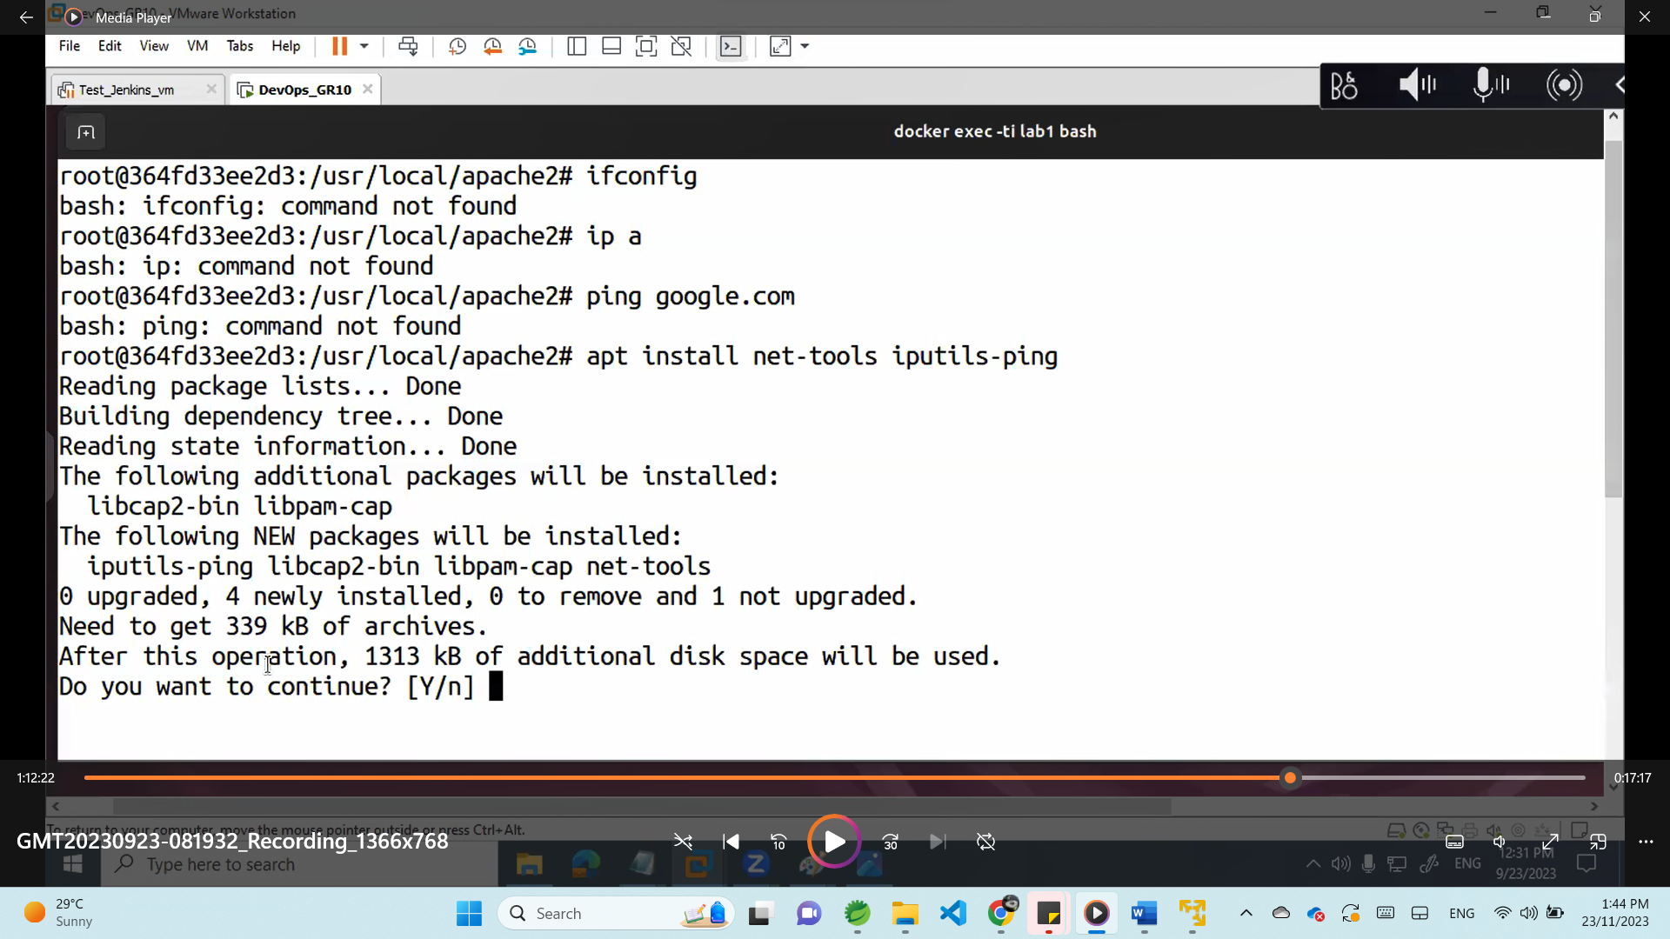

After install

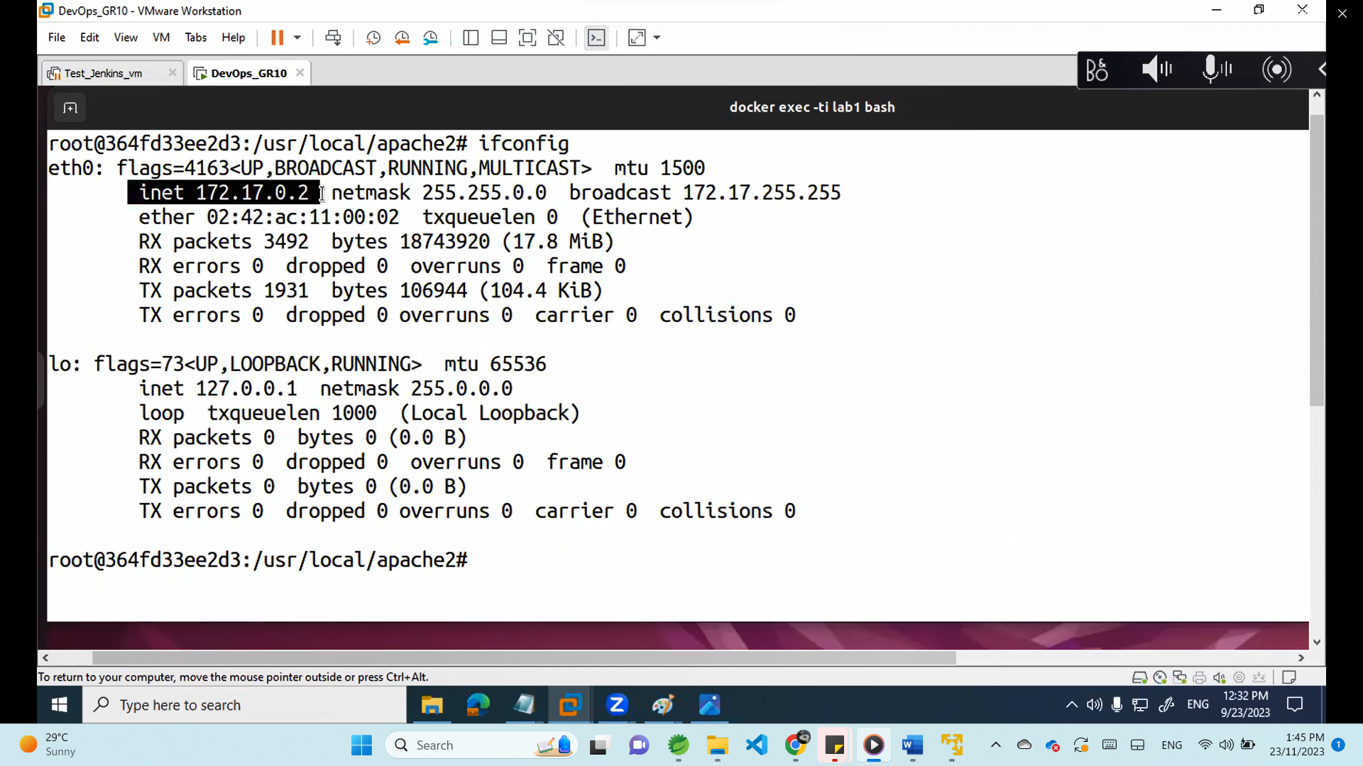

After finish all your work inside the container (exit)

Include static host name for the container

docker run -d --name lab3 --hostname ***lab3*** -p 8082:80 httpd:latest

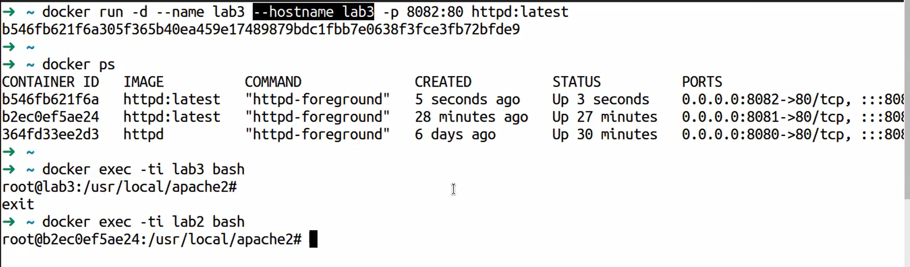

Docker run –help

And you ll find –**memory** –**CPUS** --**volumes** so we can reserve resources for the container

-Restart docker ll terminate all running containers :

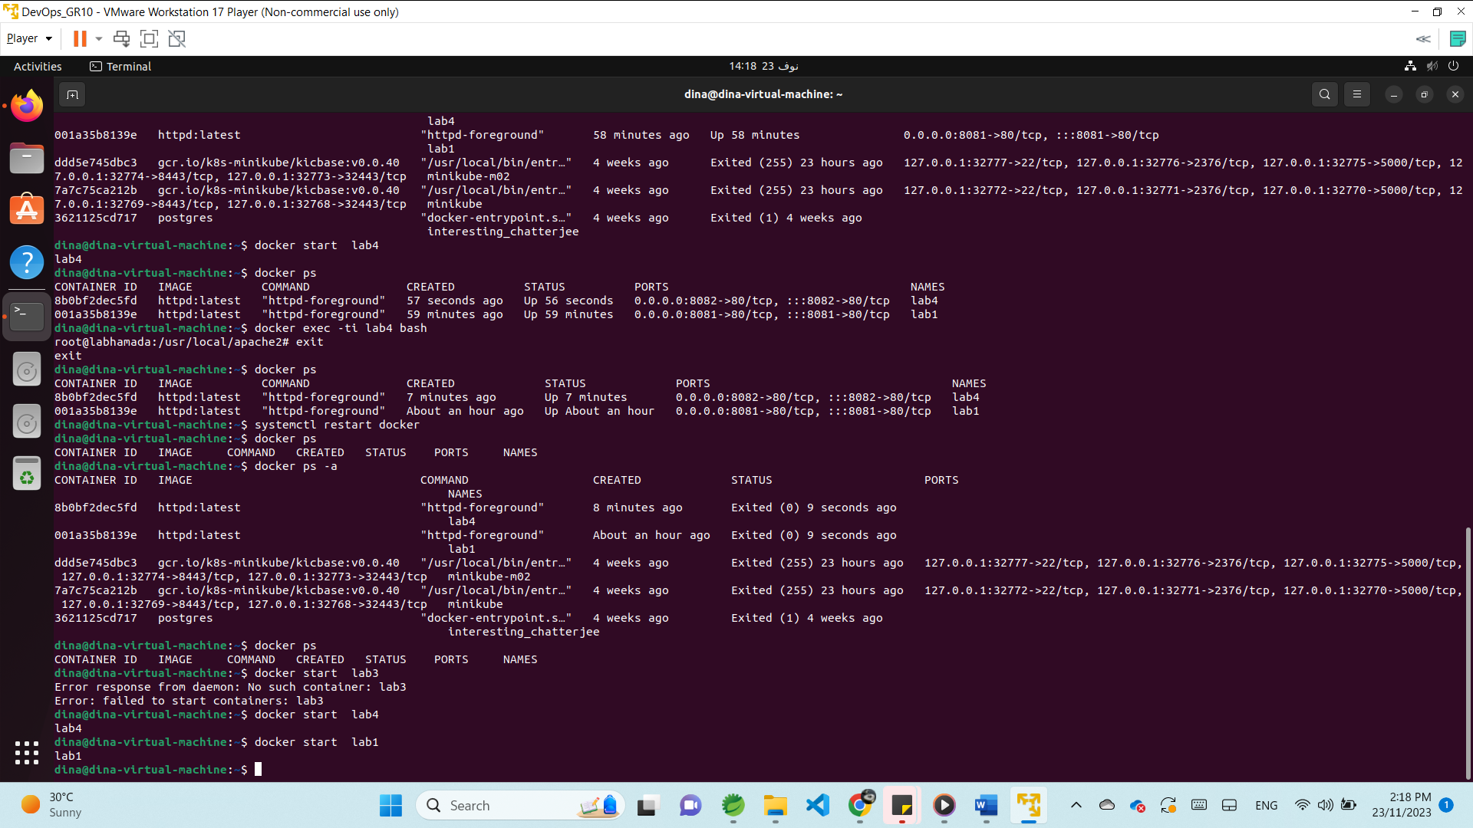

-If I want to make the containers start automatically **–restart always** when we create the container

docker run -d --name lab5 --hostname lab5-p 8083:80 **--restart always** httpd:latest

Docker Network

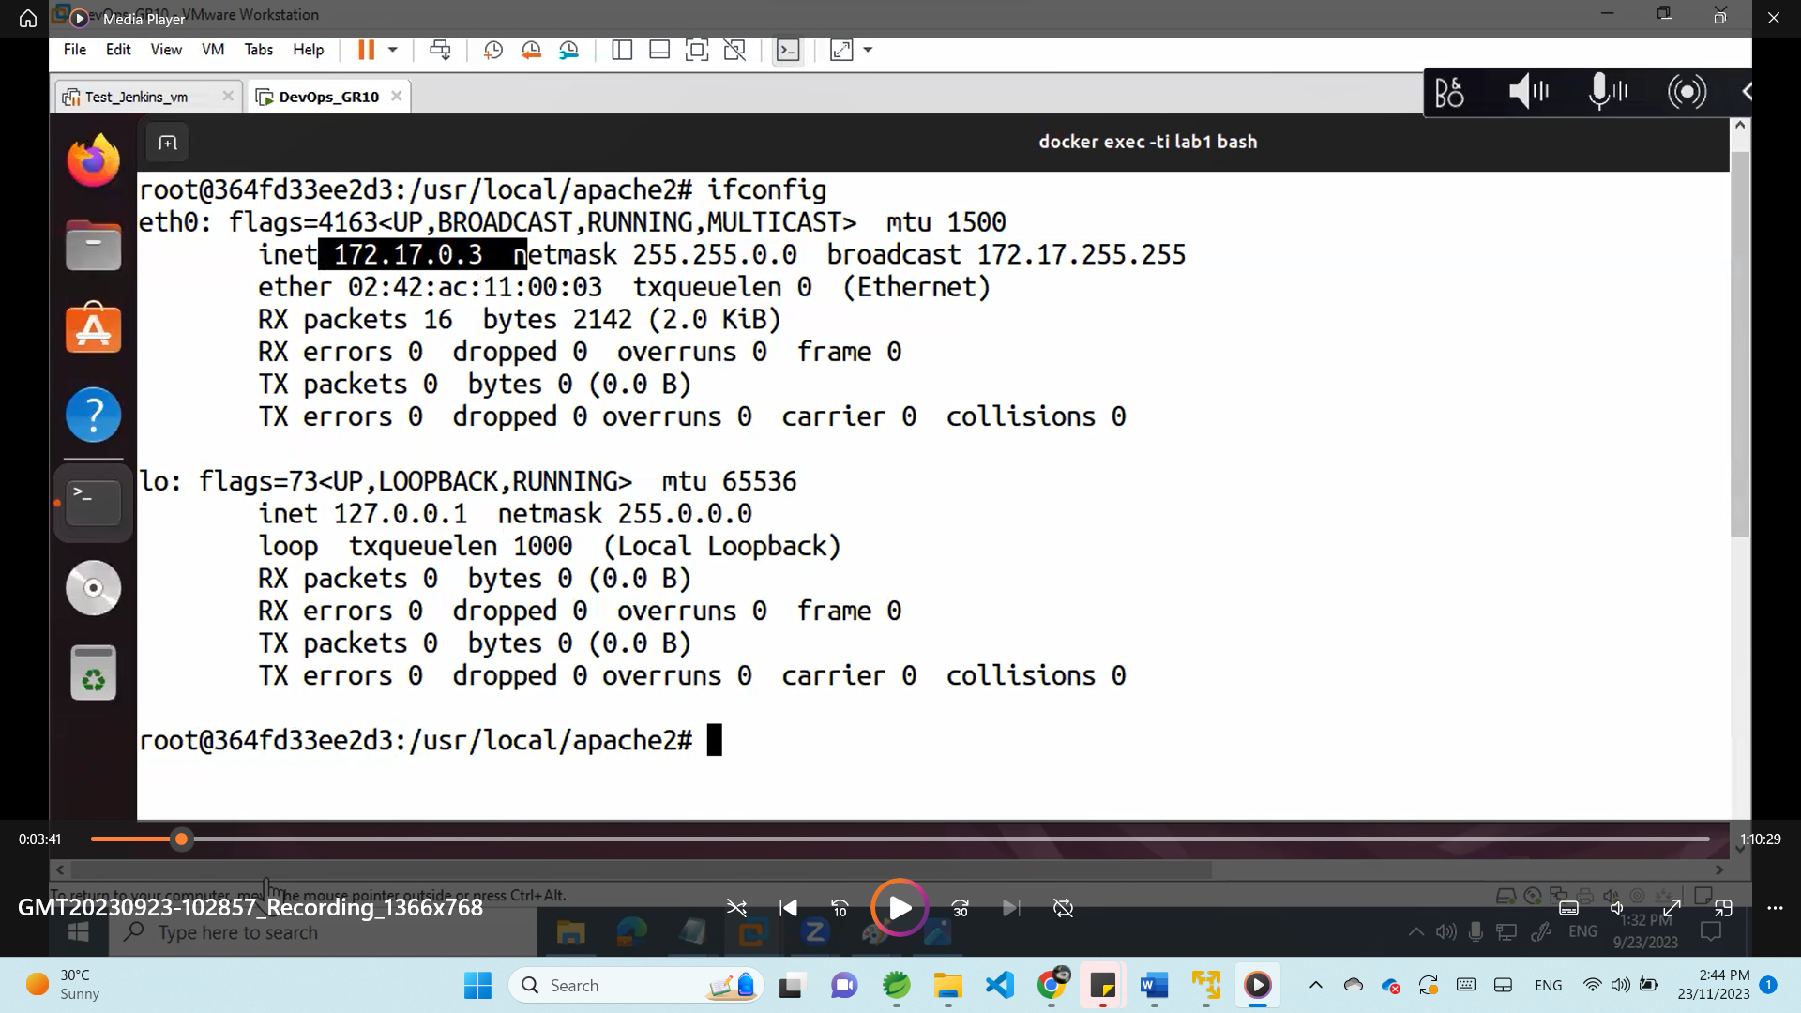

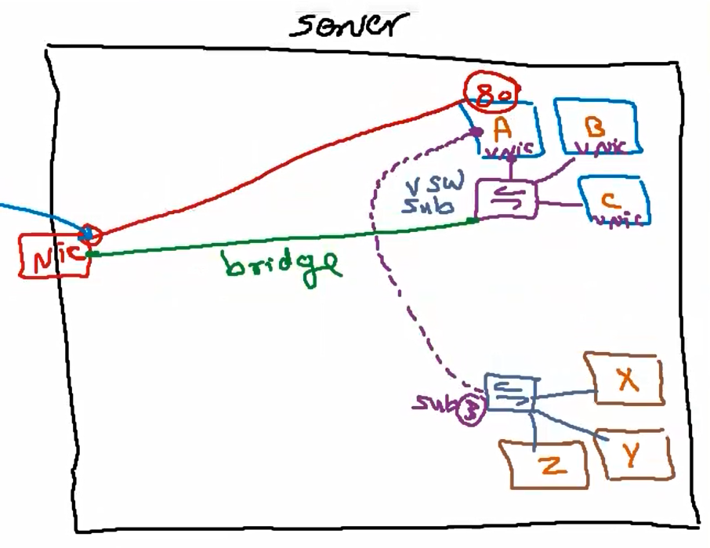

1. The containers needs to communicate 🡪 all should be in the same network (virtual switch)
2. The container can req any thing from the internet 🡪 they should be assigned to bridge

(mapping between NIC and the virtual network by CNI container network interface using bridge )

1. The containers need to be accessible for any external request 🡪port mapping
2. Container A need to access X 🡪 connect X virtual switch with A virtual NIC

CNI driver (virtual network)types:

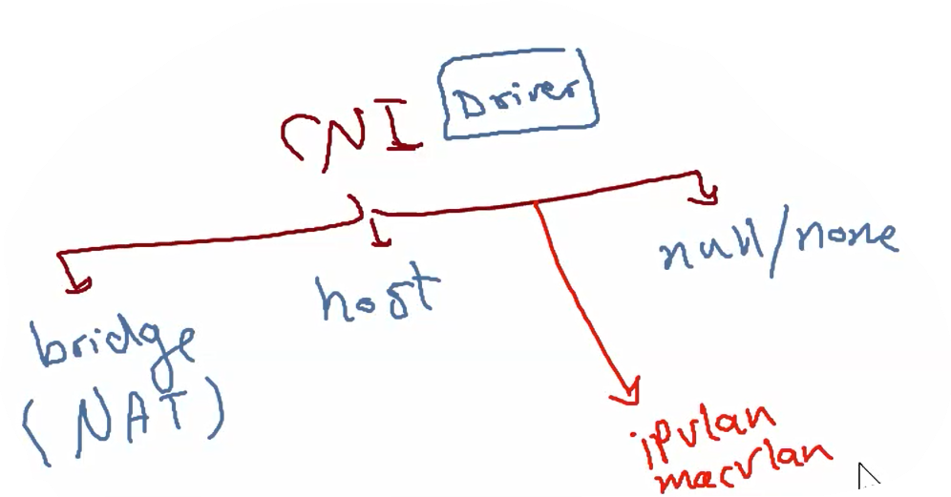  
**bridge**: all connected containers can access the internet and all can be accessed but needs port map

**Host**: host machine only can access the contains and the containers can’t connect to internet

**Null/none**: container can’t access any other containers or internet and can’t be accessed

**Ipvlan/macvlan**: used when I want the container access the internet directly

Network commands:

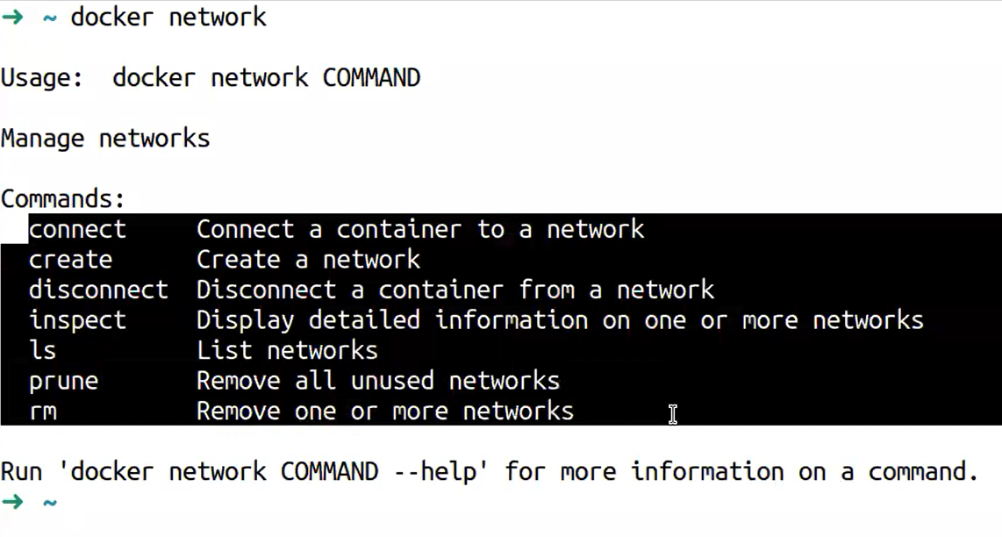

|  |  |
| --- | --- |
| Docker network ls | List all networks |
| Docker network inspect bridge | Get bridge network details |
| Docker network create senior | Create new network called senior |
| Docker network create –help | Get all available options in network create  Ex: ) subnet ,internal,driver, gateway,ip range. |
|  |  |
|  |  |
|  |  |
|  |  |

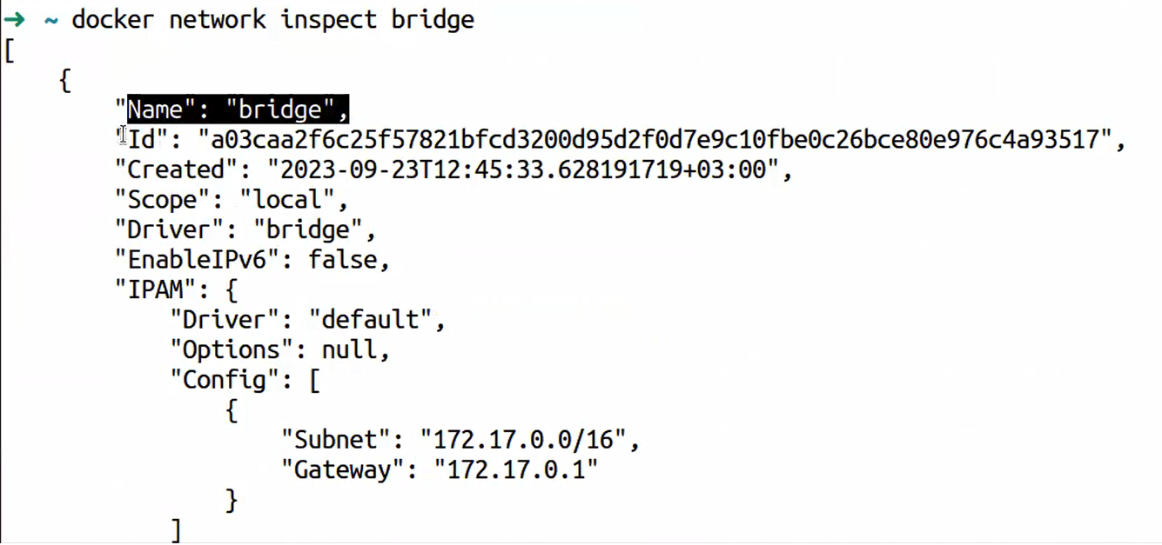

Inspect display the network details like :

-subnet and gateway

-internal if false means this network can access the internet

-containers: containers that connected to this network

**Any new container once created is assigned to bridge network by default.**

1-Create two network one internal and one able to access the internet:

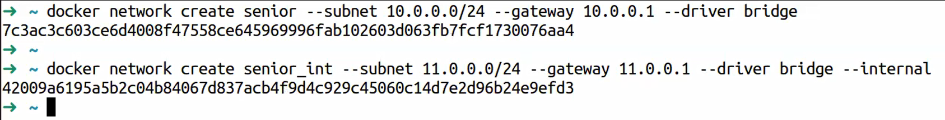

2- create container assigned to network senior and container assigned to senior_int



**We ll find the container in caontainers section if we inspect network senior**

**And we can open HostIp:7070 we can call hostIp:7070 it ll respond**

Docker file

We create file to generate image that is not exist before so we need to add our dependencies

1. My application source
2. All requirements
3. Dpends on which OS

1- search for base OS pure image 🡪 docker search rhel or docker search ubi (universal base img) ,docker search ubuntu , docker search centos …

2-pull this image

3-add to instructions [From : image]

4-

Docker Volume

Storage outside the containers if the container destroyed the volume (data) still exists and accessible.

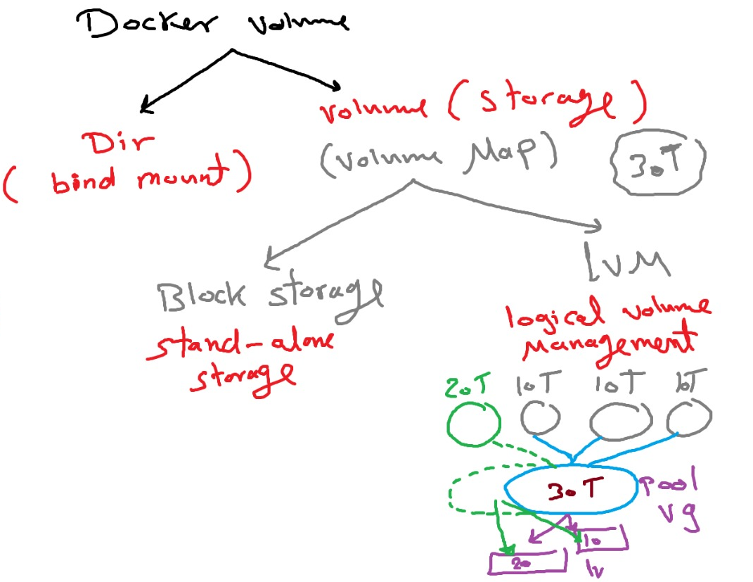

Block storage : static hard disk if we need to increase the storage we need to change the hard with bigger one 🡪 so it ll be down time

Lwm : logical volume management is a storage sw solution collect all available storage in ine logical volume group (VG) and we can create any num of partitions () so we can extends the VG storage by add more logical volume (LV) and the total storage is depends on the total storage in the VG pool

1. Docker pull mysql
2. Docker pull wordpress

|  |  |
| --- | --- |
| Lsblk | List attached disks |
| Vm -> settings->disks-> add 🡪Sata(no restart neede) ->new virtual disk ->50 GB no allocate  Check 🡪lsblk look for disk you ll find 2 disks | Add disks to my machines |
| Fdisk dev/sdb  Pvcreate dev/sdb  Vgcreate dev/sdb  Lvcreate  Mkfs  mount | Merge haed disk to create VG pool |
|  |  |